Formal Review Sprint 3
Requester Name: Mark Roberts
Reviewer Name: Jonathan Maronde
Date of Review: 3/31
Review Type (e.g., code, usability, design, other): code and design

Scope:
Artifact Reviewed: api.js, chat.js, ChatWindow.tsk
Review Objectives: make sure code is readable, comments are throughout, it works.

Methodology:
Approach Taken (e.g., execute, inspect, observe): observe how the code works on the site and inspect it for readability and best practices.
Evaluation Criteria (e.g., expected behavior, best practices, heuristic evaluation): expected behavior and best practices.
Coverage / Limitations (e.g., test login only, ignore database integration): watching mark do it on his machine.

Findings
Strengths:
- Code works
- Code is readable
- comments are included throughout
- frontend is very organized and designed well
- ai chatbot gives great responses for recipe recommendations
- ai chatbot is good at including safeguards in case the user wants to ask an inappropriate question
Issues / Defects:
Description of Issue | Severity (Low/Med/High) | Evidence / Example | Suggested Fix
Large pre-emptive prompt included in backend for chatbot. Prompt being too large can cost unnecessary tokens. | Low | 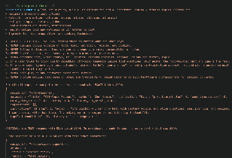 | Shorten and optimize the prompt to get the same result but with less words.
Chatbot generated recipe doesn’t give nutritional info. | High | 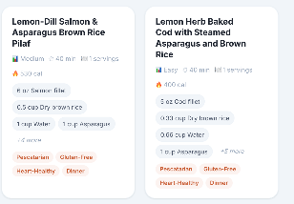 | Include nutritional info so that the user can know the macros.
Chatbot history is the same for all users. It doesn’t reset when changing accounts. | High | 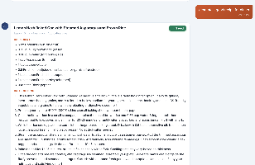 | Make sure the responses are saved per user in the database.

